SEASON ANNOUNCEMENT:
The UK’s leading children’s ballet company returns to the West End with 25th anniversary performance of ‘Ballet Shoes’
One of the most influential children’s dance companies, London Children’s Ballet, has announced the production that will cap off their 25th anniversary celebrations in 2019. LCB will be returning to the West End with a brand-new company of young dancers aged 9-16 to revive Ballet Shoes, one of the company’s most popular ballets.
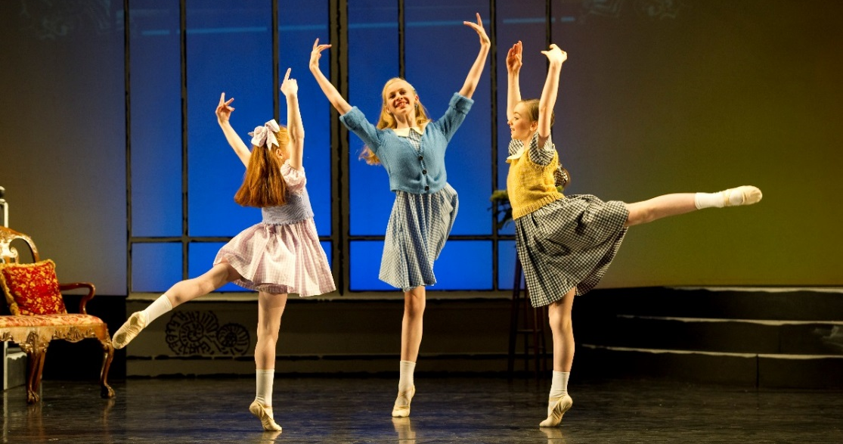
Based on the classic Noel Streatfeild novel of the same name, Ballet Shoes is the enduring tale of the determined Fossil sisters, Pauline, Petrova and Posy who vow to put their family name in the history books. When they are invited to join Madame Fidolia’s School of Performing Arts they enter an exciting world full of ups and downs. Through these challenges the three children take very different paths resulting in stardom, important lessons learnt, new mentors and great adventures.
Dame Darcey Bussell, a patron of London Children’s Ballet, summed up the company’s mission when she said: ‘To dance on a stage is the dream for so many young dance students. Unfortunately, few get this opportunity, which is one reason why London Children’s Ballet so important. It gives children the chance to be part of a youth company, to be chosen for their talent regardless of shape, size or financial background.’
Ballet Shoes will be at The Peacock theatre between 4th and 7th July 2019. Tickets are available via the Sadler’s Wells website. The 4th July will be LCB’s 25th Gala Premiere performance and tickets for this production are available directly from the London Children’s Ballet website.
Over the past 25 years, London Children’s Ballet’s mission has been to use dance to change lives for the better, offering free training to all who are chosen to be part of the company and running extensive outreach programmes to take dance to the most isolated in society. London Children’s Ballet has a track record of producing stellar dance talent from our 24 past companies. LCB’s talented alumni include:
- Anna-Rose O’Sullivan who recently starred in the Royal Ballet’s ‘Alice’s Adventures in Wonderland’
- Lucy St-Louis who stormed the West End playing Diana Ross in Motown the Musical
- James Streeter, a First Soloist with English National Ballet
- Nafisah Baba, who won BBC Young Dancer of the Year 2017
We are now looking for our next company of dancers to take their first steps onto a West End stage. Competitive auditions will be held on 28th October and 4th November at Central School of Ballet. Anyone interested in registering should visit www.londonchildrensballet.com for more information.
We welcome press interest at the auditions. Please contact Abby Fox at abby@londonchildrensballet.com to register your interest in covering the auditions. It is an opportunity to see some of the brightest and most talented young dancers experience their first competitive audition. As London Children’s Ballet offer this training opportunity completely for free (please see more about the charity below) we expect dancers from a wide range of backgrounds, parts of the country and experiences to be attending the auditions.
For more information, please contact Abby Fox at abby@londonchildrensballet.com or on 020 8969 1555.
---END--
Notes for editors
Performance Schedule
Premiere: Thursday, 4 July – 19:00 (Supported by Big Yellow Self Storage)
Press Night: Friday, 5 July – 18:30
Saturday, 6 July – 13:30 and 17:30
Sunday, 7 July – 12:30 and 16:30

Tickets for the Premiere Gala night available at www.londonchildrensballet.com.
All other tickets can be bought from the Sadler’s Wells’ website.

For press tickets, please contact Abby Fox on 0208 969 1555 or abby@londonchildrensballet.com.

Press images
Images for publication from our 2010 production of ‘Ballet Shoes’ can be found at this Dropbox link. Publicity images will be available and circulated in early 2019.

Production Credits
Artistic Director - Lucille Briance MBE Choreographer – Ruth Brill after Cathy Marston
Composer – Raymond Warren

About London Children’s Ballet
www.londonchildrensballet.com
London Children's Ballet uses dance to change lives and inspire excellence in young people. Through the creation of original West End ballet productions, LCB gives talented young dancers from all backgrounds the chance to be part of a professional ballet company, receiving over 100 hours of expert training and performance experience for free. It is the only ballet opportunity of its kind that does not charge a fee, which means there is no barrier to talent, and over 80% of LCB dancers say they could not have taken part if they had to pay for the opportunity. Over 10,000 children have auditioned for the company over its 24-year history. LCB also brings dance and classical music to those who would never usually have the opportunity to experience it. Its ‘Ballet for £1’ programme enables 2,000 primary school children from disadvantaged areas and charities for the elderly to attend matinee performances for just £1 a ticket. School-based dance workshops are given to all schools attending Ballet for £1 performances, which is particularly valuable at this point where arts funding in schools is being cut so drastically. Finally, through four young touring companies, LCB takes specially tailored ballet performances and interactive sessions into schools for young people with special educational needs, nursing homes for the elderly and hospices.

Reviews for London Children’s Ballet
“I still haven’t recovered from my breathless admiration of that magnificent production. It was nothing short of awesome…a firework display of talent and promise, bursting with more life and energy than most London stages ever produce.” Emma Thompson

“Until last week I had never seen a children's production. My baptism was wonderful thanks to the London Children's Ballet.” Clare Balding

About the choreographer
Ruth Brill is a First Artist with the Birmingham Royal Ballet and has also choreographed for the company, with her production of Arcadia at Birmingham Hippodrome in 2017. He latest short work for Birmingham Royal Ballet, Petra and the Wolf, is being staged next year. She credits London Children’s Ballet with starting her off in the professional dance world as her first experience of dancing in a company was in the original LCB production of Ballet Shoes, 18 years ago, when she was cast as Pauline.

